**Graphics and Animation Tools**

**LAB**

**Experiment – 1 Installation of GIMP and Blender.**

**Installation of GIMP :-**

**Step – 1:**

Download the GIMP installer. You can download this for free from gimp.org/downloads and click on the Download GIMP 2.10.20 directly.

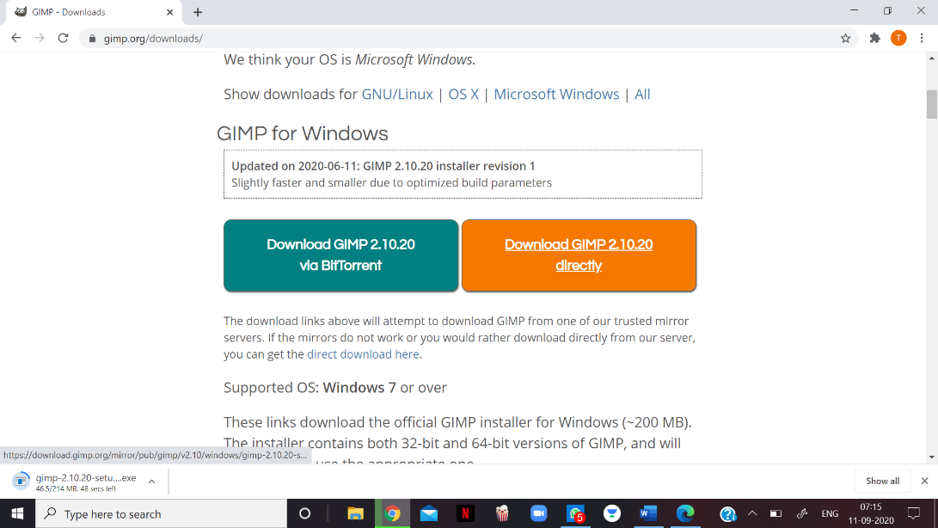

**Step – 2:**

Run the GIMP installer.

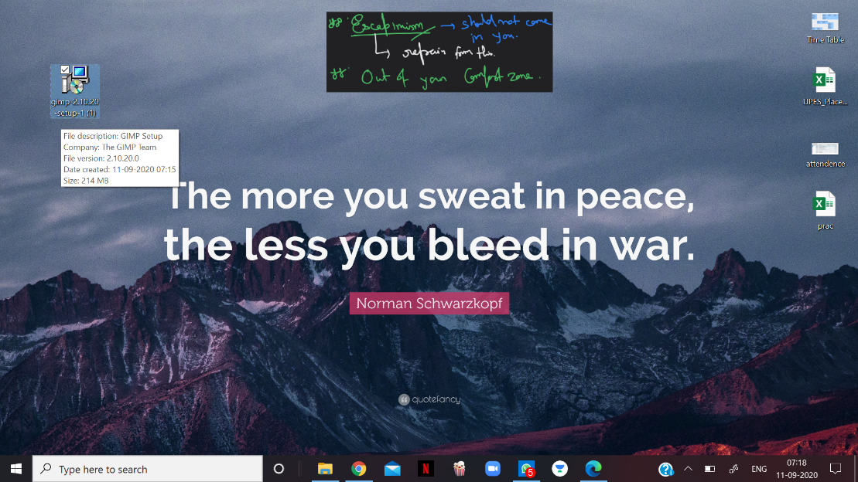

**Step – 3:**

Choose the language you want. (by default- English)

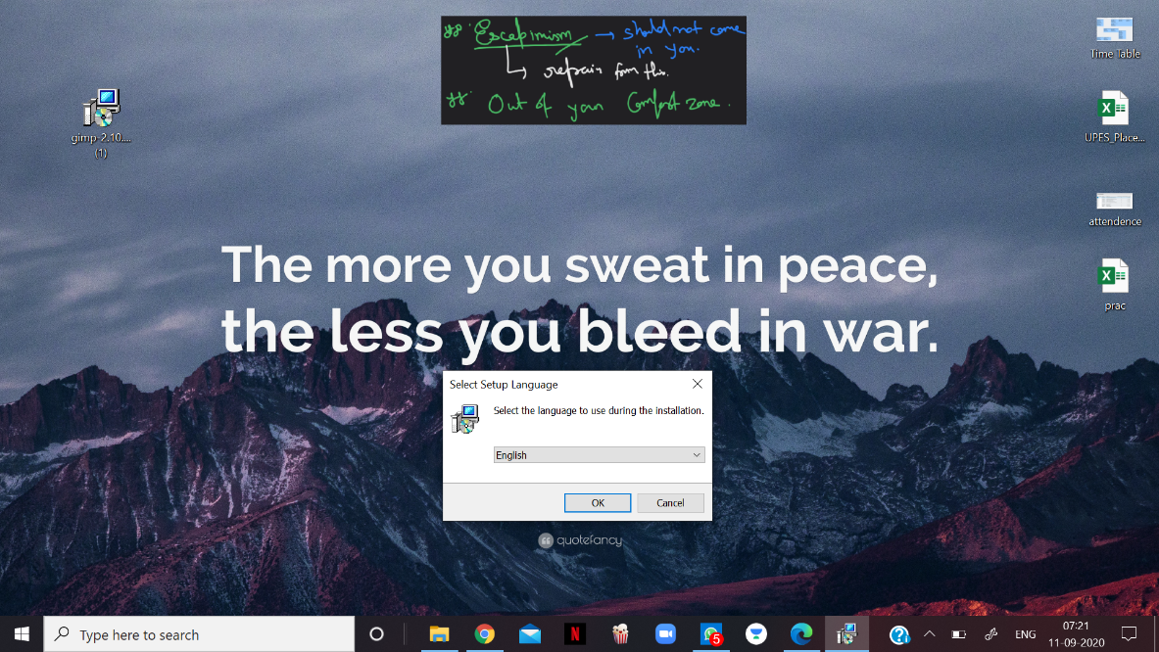

**Step – 4:**

Follow the prompts to install GIMP. Click the install button to start installing.

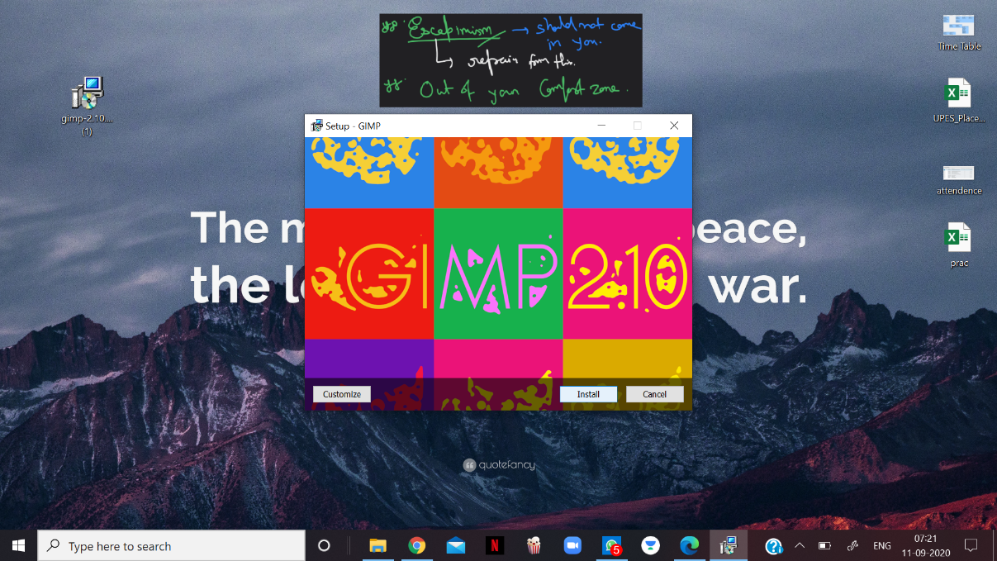

**Step – 5:**

Finish the installation by clicking at finish.

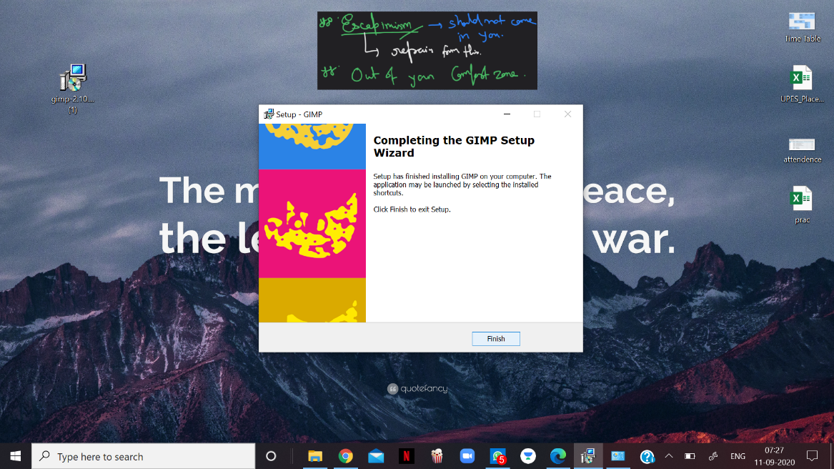

**Step – 6:**

Once GIMP has finished installing, you can start using it.

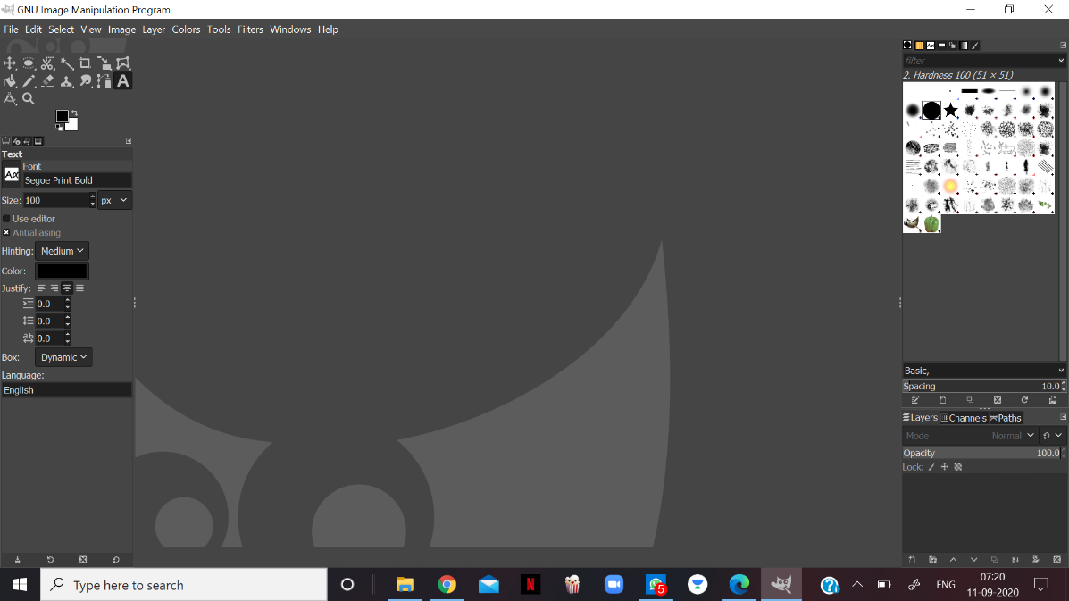

**Installation of Blender :-**

**Step – 1:**

Visit the Blender Website and download the latest version (v 2.90)

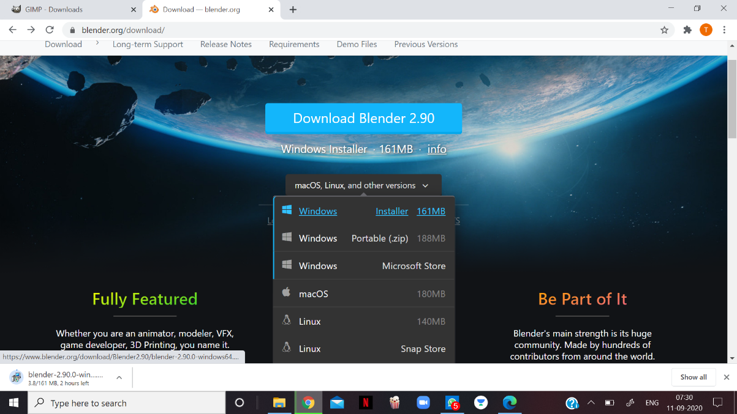

**Step – 2:**

Run the downloaded Installer setup.

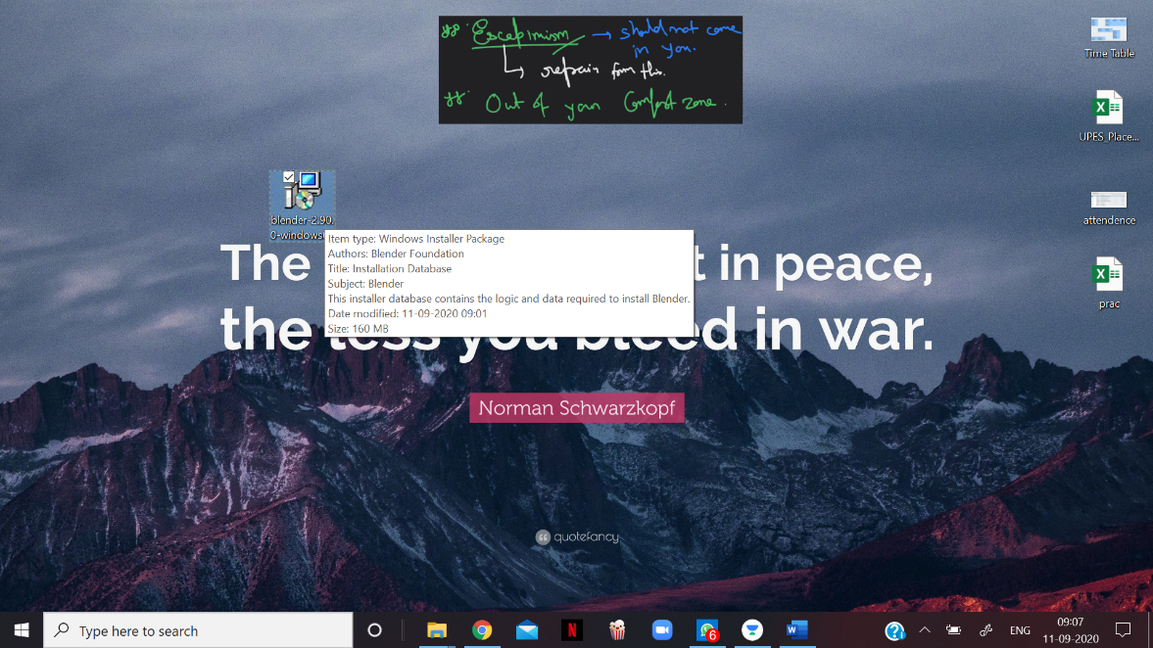

**Step – 3:**

Now, click on the Next Button to initiate the installation process.

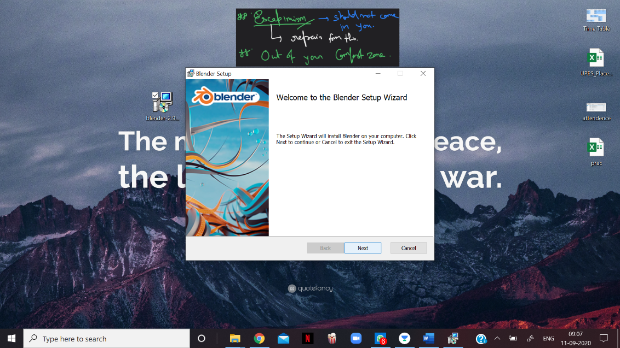

**Step – 4:**

Click on the Next Button, when asked to move ahead in the process.

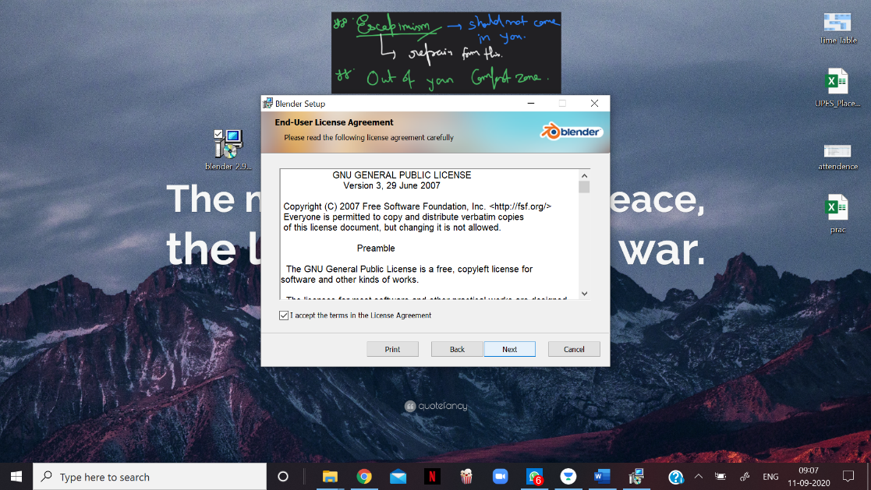

**Step – 5:**

Click on Finish and complete the Installation Blender process.

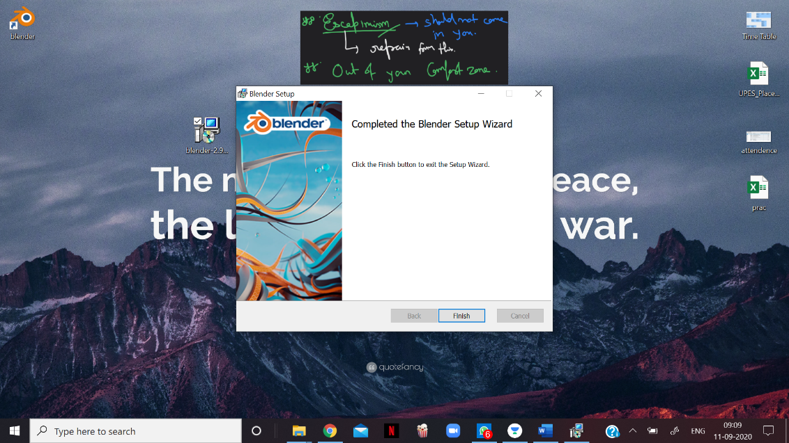

**Step – 6:**

After installing the program, the Blender window will look like this.

